|  |  |  |  |
| --- | --- | --- | --- |
| 1 | | 9,978 | |
| **NUMERO DE FRONTERAS** | | **ENERGIA AGREGADA** | |
|  | | | |
| 25,644,320 | 99 | | 960,852 |
| INGRESO 2020 | DÍAS CERTIFICADOS 2020 | | ENERGIA RESPALDADA 2020 |
|  | | | |
| 18,883,780 | 89 | | 825,388 |
| INGRESO 2021 | DÍAS CERTIFICADOS 2021 | | ENERGIA RESPALDADA 2021 |

**HISTORICO REINTEGRO DDV**

|  |  |  |
| --- | --- | --- |
|  | **2020** | **2021** |
| **ENE** | - | 3.85 |
| **FEB** | 0.12 | 4.89 |
| **MAR** | 3.58 | 0.47 |
| **ABR** | - | 0.73 |
| **MAY** | 0.85 | 5.83 |
| **JUN** | 5.95 | 1.25 |
| **JUL** | 7.24 | 1.86 |
| **AGO** | 5.35 | - |
| **SEP** | 1.34 | - |
| **OCT** | 0.93 | - |
| **NOV** | - | - |
| **DIC** | 0.28 | - |

**Los valores de la tabla están en millones de COP**



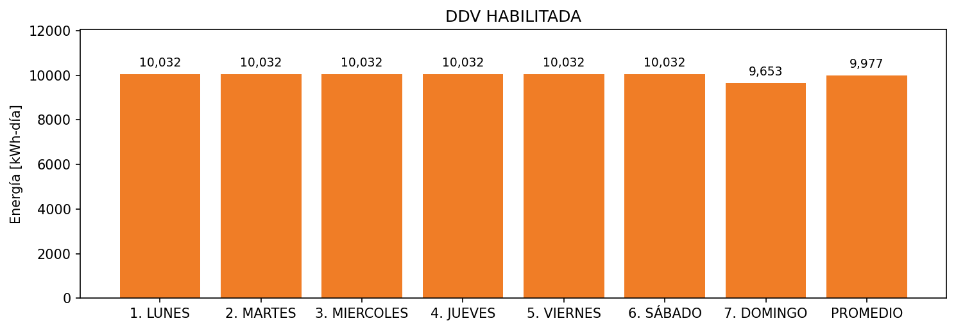

|  |  |  |  |  |  |  |  |  |  |
| --- | --- | --- | --- | --- | --- | --- | --- | --- | --- |
| **FRONTERA** | **COD SIC** | **FRT DDV** | **TIPO DDV** | **PROMEDIO** | **PRÓXIMA ACTUALIZACIÓN** | **MARGEN DE ERROR** | **ÚLTIMA PRUEBA DDV** | **DÍAS PARTICIPACIÓN** | **FECHA REFERENCIA PRÓXIMA PRUEBA DDV** |
| EMPAQUES TRANSPARENTES LTDA. | Frt01097 | Frt36400 | LBC | 9,977 | 2022-03-11 | 11,48 | 2020-12-24 | 89.0 | 2021-12-17 |